**JAVA JSP**

**What Is a JSP Page?**

A **JSP page** is a text document that contains two types of text: static data, which can be expressed in any text-based format (such as [HTML](http://www.w3.org/MarkUp/), [SVG](http://www.w3.org/TR/SVG), [WML](http://xml.coverpages.org/wap-wml.html), and [XML](http://www.w3.org/TR/REC-xml/)), and JSP elements, which construct dynamic content.

The recommended file extension for the source file of a JSP page is .jsp. The page can be composed of a top file that includes other files that contain either a complete JSP page or a fragment of a JSP page. The recommended extension for the source file of a fragment of a JSP page is .jspf. The JSP elements in a JSP page can be expressed in two syntaxes, standard and XML, though any given file can use only one syntax. A JSP page in XML syntax is an XML document and can be manipulated by tools and APIs for XML documents.

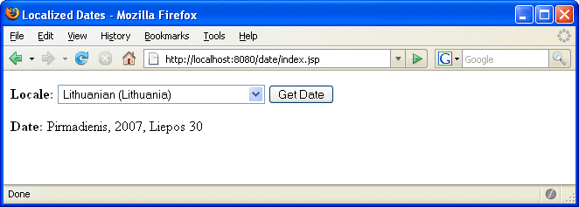

**JSP Construct Types**

* A content type is set with this particular directive and will brought back to the page: (**<%@page ... %>**)
* A directive where custom tag libraries are imported: (**<%@taglib ... %>**)
* Objects created with a package containing locales and identifiers that directs to a object as a standard element is called a **jsp:bean.**
* There are object properties that call the value of JSP expressions under the language expressions and these are (**${ }**). Values are recycled are used to establish custom tag attribute values and build content that is dynamic.
* A variable is determined as a custom tag it is called (**c:set**), a collection is emphasized locale names called (**c:forEach**),and tentatively HTML text is inseted in the response.
* Another standard element that appoints a value of a certain property of an object this is the **jsp:setProperty**
* This function test equality of the attributes and the collection’s present item there is also an inherited operator, ==, and is used for testing the equality. (**f:equals**)

**Here is a JSP page example:**

<%@ **page contentType**="text/html; charset=UTF-8" %>

<%@ **taglib** uri="http:/java.net/http/jsp"

prefix="j" %>

<%@ **taglib** uri="/functions" prefix="functions" %>

<html>

<head><title>Dates Decentralized</title></head>

<body bgcolor="yellow">

<**jsp:useBean** id="locales" scope="application"

class="mypkg.MyLocales"/>

<form name="localeForm" action="index.jsp" method="post">

<**j:set** var="selectedLocaleString" value="**${param.locale}**" />

<**j:set** var="selectedFlag"

value="**${!empty selectedLocaleString}**" />

<b>Locale:</b>

<select name=locale>

<**j:forEach** var="localeString" items="**${locales.localeNames}**" >

<**j:choose**>

<**j:when** test="**${selectedFlag}**">

<**j:choose**>

<**j:when**

test="**${f:equals(selectedLocaleString, localeString)}**" >

<option selected>**${localeString}**</option>

</j:when>

<j:otherwise>

<option>**${localeString}**</option>

</j:otherwise>

</j:choose>

</j:when>

<**j:otherwise**>

<option>**${localeString}**</option>

</j:otherwise>

</j:choose>

</j:forEach>

</select>

<input type="submit" name="Submit" value="Get Date">

</form>

<**j:if** test="${selectedFlag}" >

<**jsp:setProperty** name="locales"

property="selectedLocaleString"

value="**${selectedLocaleString}**" />

<**jsp:useBean** id="date" class="mypkg.MyDate"/>

<**jsp:setProperty** name="date" property="locale"

value="**${locales.selectedLocale}**"/>

<b>Date: </b>**${date.date}**</c:if>

</body>

</html>